Upload widget is only available when the cell has been executed in the current browser session. Please rerun this cell to enable.
Saving sales_dat_.csv to sales_dat_ (2).csv
Date Product Sales Quantity Region
0 2023-01-01 Product F 310 9 West
1 2023-01-01 Product D 376 3 East
2 2023-01-01 Product B 413 5 South
3 2023-01-01 Product C 138 2 North
4 2023-01-01 Product B 262 7 North
Date 0
Product 0
Sales 0
Quantity 0
Region 0
dtype: int64
Sales Quantity
count 1000.000000 1000.000000
mean 298.320000 5.428000
std 114.106959 2.841283
min 100.000000 1.000000
25% 206.750000 3.000000
50% 293.000000 5.000000
75% 393.250000 8.000000
max 500.000000 10.000000
Product Sales Quantity
0 Product A 47109 930
1 Product B 51425 928
2 Product C 52466 927
3 Product D 47028 834
4 Product E 50367 912
5 Product F 49925 897
/tmp/ipykernel_3969/1980125300.py:13: FutureWarning: A value is trying to be set on a copy of a DataFrame or Series through chained assignment using an inplace method.
The behavior will change in pandas 3.0. This inplace method will never work because the intermediate object on which we are setting values always behaves as a copy.

For example, when doing 'df[col].method(value, inplace=True)', try using 'df.method({col: value}, inplace=True)' or df[col] = df[col].method(value) instead, to perform the operation inplace on the original object.

df['Sales'].fillna(df['Sales'].mean(), inplace=True)
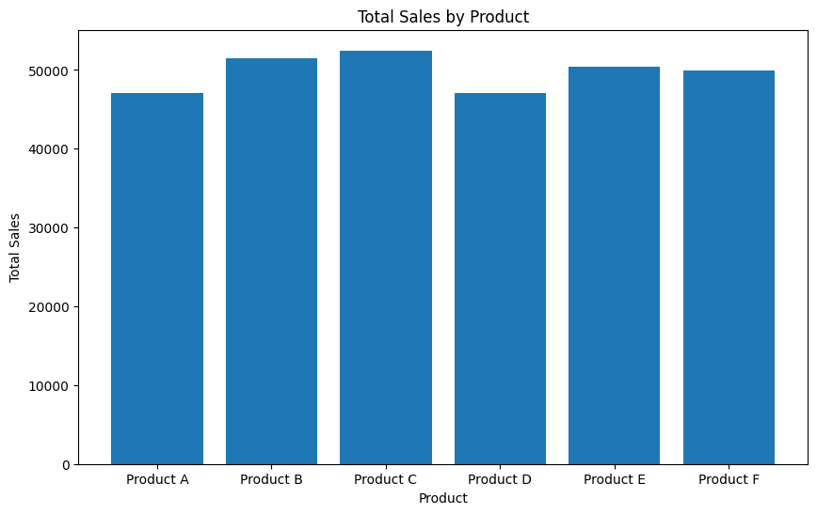
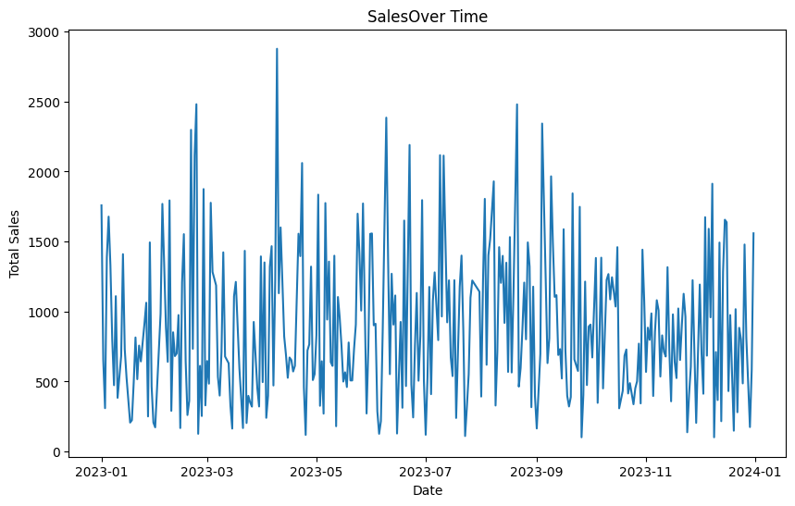
/tmp/ipykernel_3969/1980125300.py:42: FutureWarning: The provided callable <function sum at 0x7b0229584ea0> is currently using DataFrameGroupBy.sum. In a future version of pandas, the provided callable will be used directly. To keep current behavior pass the string "sum" instead.
pivot_table = df.pivot_table(values='Sales', index='Region', columns='Product',
Product Product A Product B Product C Product D Product E Product F
Region
East 11272 13867 13076 11312 15339 12310
North 12139 14306 15011 11439 13301 14322
South 10436 12310 11740 14730 9390 12078
West 13262 10942 12639 9547 12337 11215
Sales Quantity
Sales 1.000000 -0.009034
Quantity -0.009034 1.000000
